22. Roles and Hierarchies - 25 March 2022

**Record Sharing Types:**

1] Manual Sharing

2] Sharing Rules (Automatic Sharing)

- Based on the Record Owner

- Based on the Criteria

3] Roles and Hierarchies

4] Apex Sharing (Coding)



3] Roles and Hierarchies



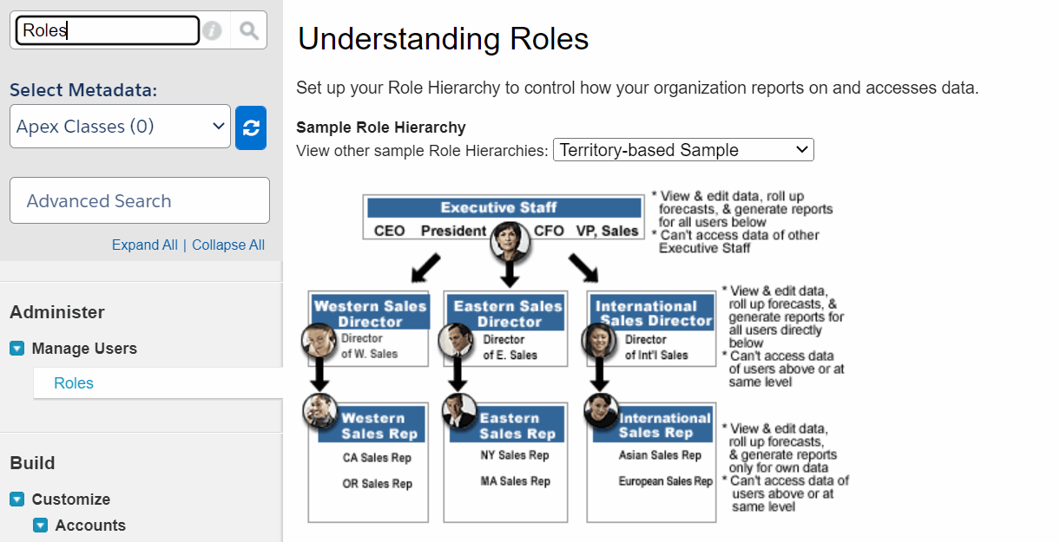

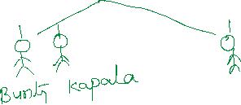

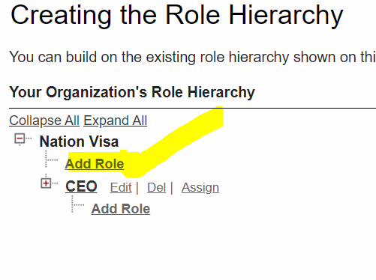

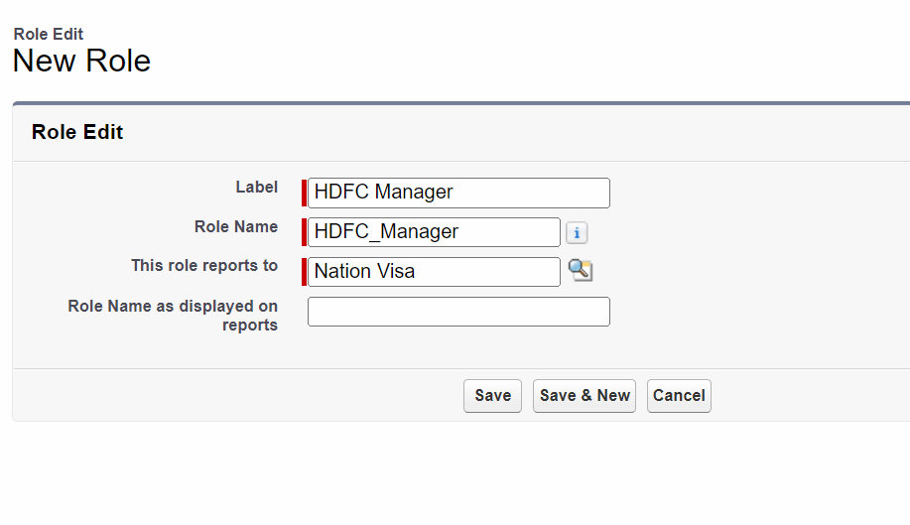

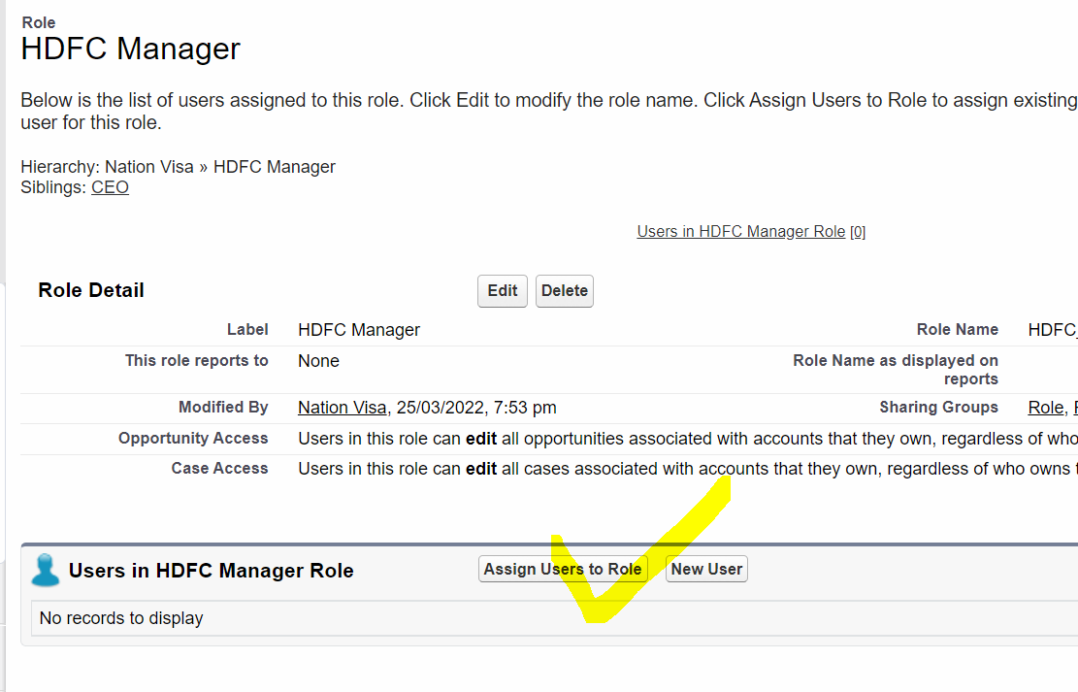

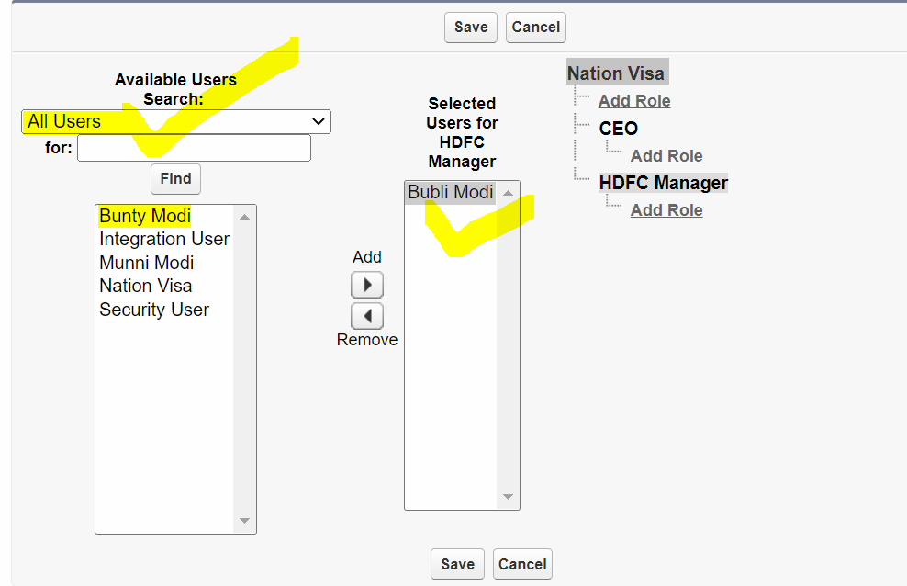

VERY IMPORTANT :

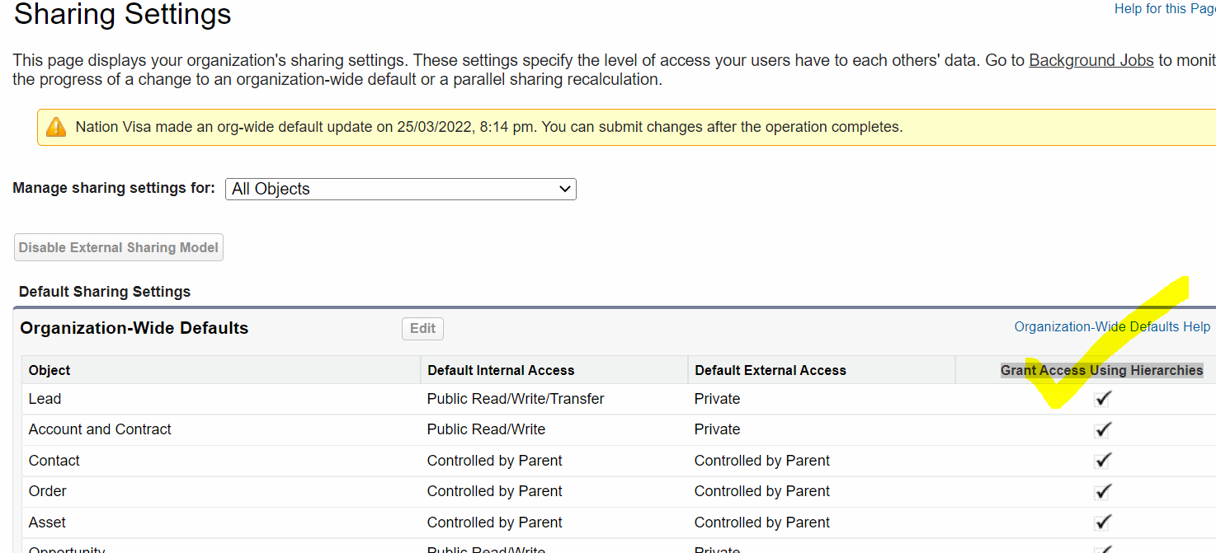

1] Diff between Profile and Role

2] Object Level Scenario Based.

3] Record sharing